Project Name:





This code is developed by:-Tata Sai Vineeth

This code for this project is hosted at:-

<https://github.com/Sai153793/CI-CD-Deployment-for-spring-boot-application.git>

# Overview

**Project Objective:**

As a Full stack Developer, you have to build a CI/CD pipeline to demonstrate continuous deployment and host the application on AWSEC2 instance.

# Goals

As the Project is in the ﬁnal stage, management has asked you to automate the integration and deployment of the web application. You are required to set up an environment where the application will be hosted and accessed by users. The source code is supposed to be fetched from a GitHub repository.

# Toolsused

* Eclipse
* GitHub
* Jenkins
* AWSEC2/Virtualmachine

# Speciﬁcations

● Apart of the source code should be tracked on the GitHub repository. You need to document the tracked ﬁles that are ignored during the ﬁnal push to the GitHub repository.

● The submission of your GitHub repository link is mandatory. In order to track your task, you need to share the link of the repository in the document.

● The step-by-step process involved in completing this task should be documented.

# ProjectExplorer

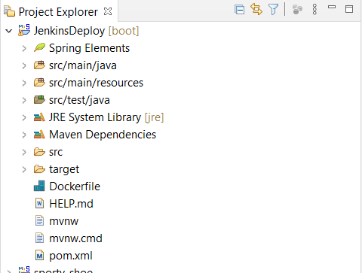

**Sourcecode**

**User**

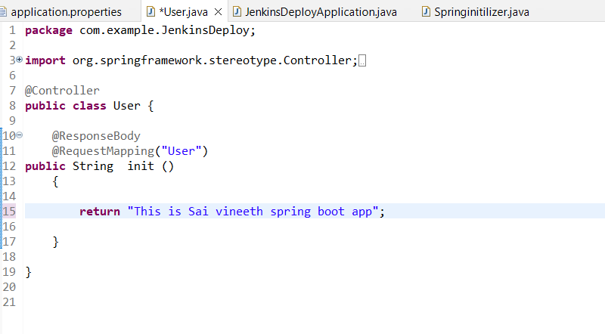

**DockerFile**

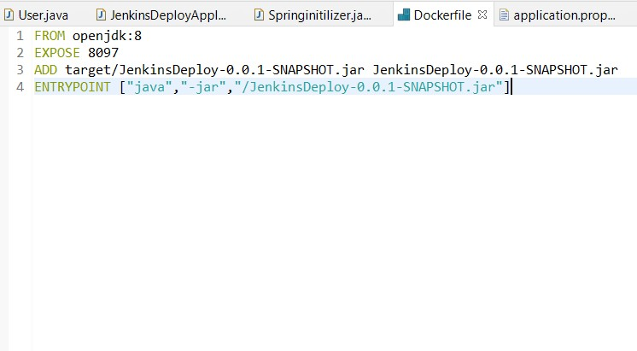

**GitHubRepository**

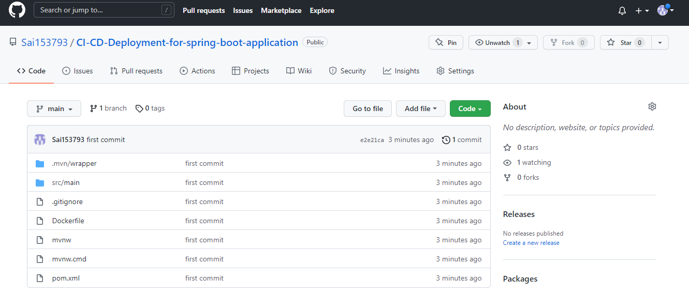



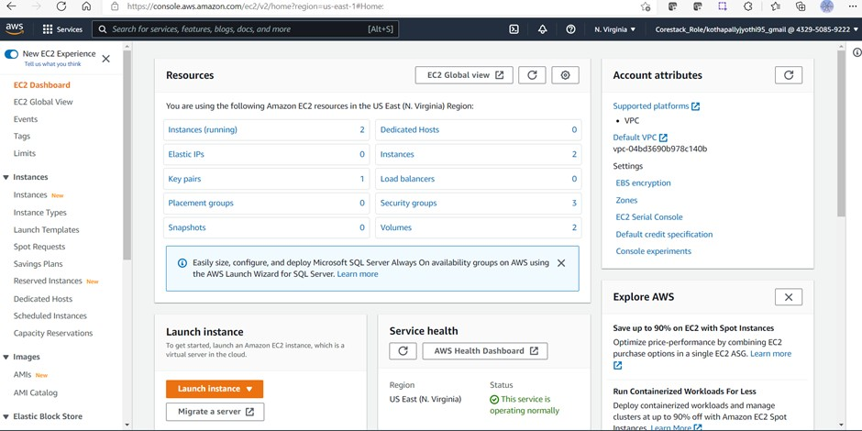

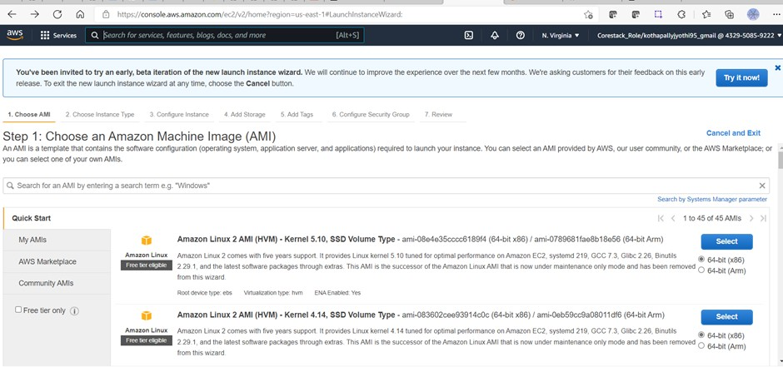



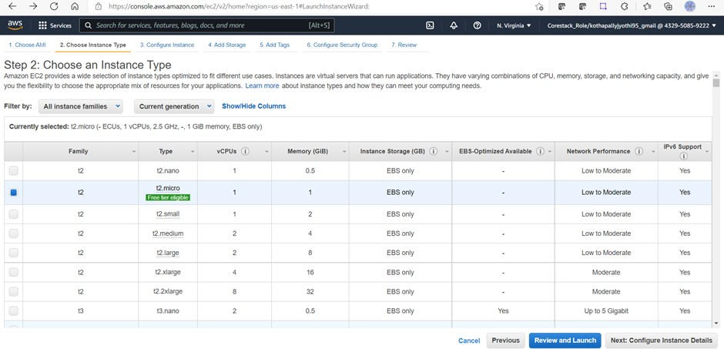

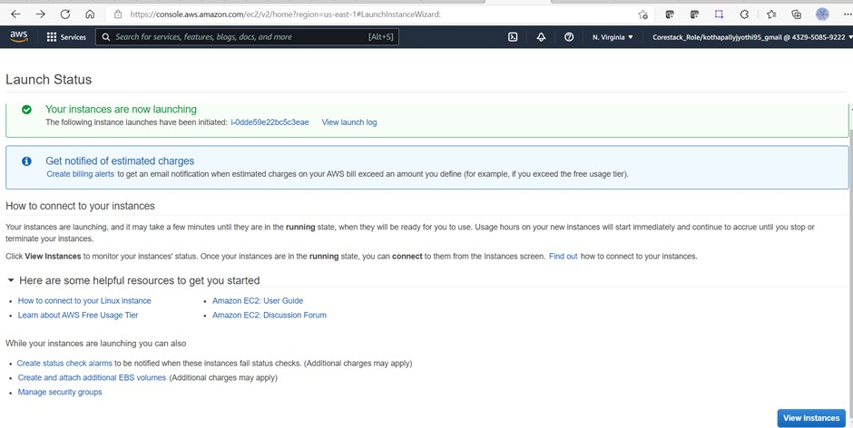



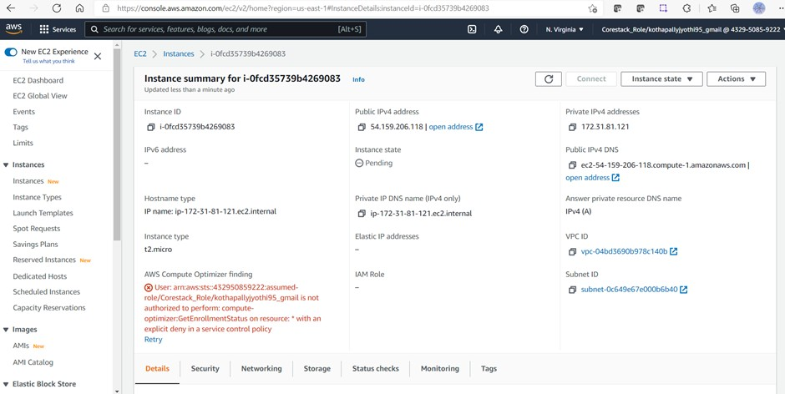

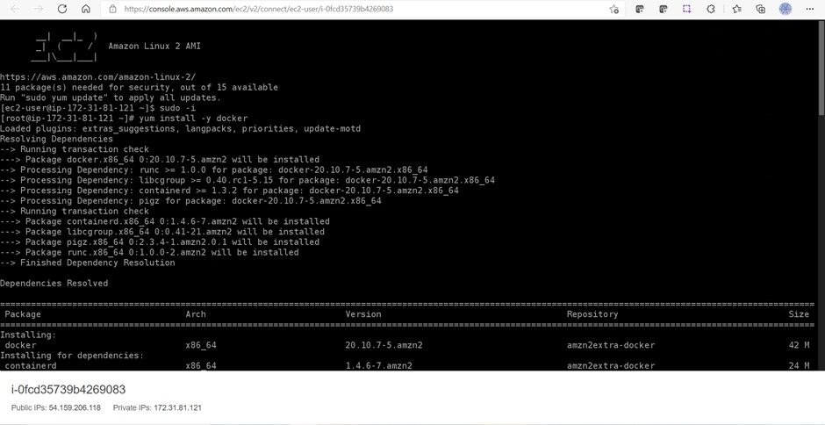



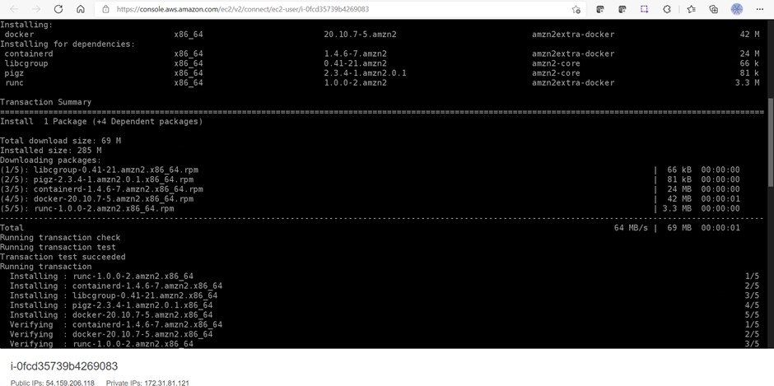

**Output:**